Natural Language Processing (NLP)
NLTK is a toolkit build for working with NLP in Python. It provides us various text processing libraries with a lot of test datasets.
Installing NLTK:
pip install nltk

Tokenization:
The breaking down of text into smaller units is called tokens. tokens are a small part of that text.

import nltk
nltk.download('punkt')
from nltk.tokenize import sent_tokenize, word_tokenize

text = "Natural language processing is an exciting area. Huge budget have been allocated for this."

print(sent_tokenize(text))
print(word_tokenize(text))

['Natural language processing is an exciting area.', 'Huge budget have been allocated for this.']
['Natural', 'language', 'processing', 'is', 'an', 'exciting', 'area', '.', 'Huge', 'budget', 'have', 'been', 'allocated', 'for', 'this', '.']

Lower case conversion:

text = text.lower()
words = text.split()
print(words)

# output -> ['natural', 'language', 'processing', 'is', 'an', 'exciting', 'area', 'huge', 'budget', 'have', 'been', 'allocated', 'for', 'this']
Stop Words removal:
stopwords – a collection of words that don’t provide any meaning to a sentence.
With NLTK we can see all the stop words available in the English language.

from nltk.corpus import stopwords

print(stopwords.words("english"))

# output->
['i', 'me', 'my', 'myself', 'we', 'our', 'ours', 'ourselves', 'you', "you're", "you've", "you'll", "you'd", 'your', 'yours', 'yourself', 'yourselves', 'he', 'him', 'his', 'himself', 'she', "she's", 'her', 'hers', 'herself', 'it', "it's", 'its', 'itself', 'they', 'them', 'their', 'theirs', 'themselves', 'what', 'which', 'who', 'whom', 'this', 'that', "that'll", 'these', 'those', 'am', 'is', 'are', 'was', 'were', 'be', 'been', 'being', 'have', 'has', 'had', 'having', 'do', 'does', 'did', 'doing', 'a', 'an', 'the', 'and', 'but', 'if', 'or', 'because', 'as', 'until', 'while', 'of', 'at', 'by', 'for', 'with', 'about', 'against', 'between', 'into', 'through', 'during', 'before', 'after', 'above', 'below', 'to', 'from', 'up', 'down', 'in', 'out', 'on', 'off', 'over', 'under', 'again', 'further', 'then', 'once', 'here', 'there', 'when', 'where', 'why', 'how', 'all', 'any', 'both', 'each', 'few', 'more', 'most', 'other', 'some', 'such', 'no', 'nor', 'not', 'only', 'own', 'same', 'so', 'than', 'too', 'very', 's', 't', 'can', 'will', 'just', 'don', "don't", 'should', "should've", 'now', 'd', 'll', 'm', 'o', 're', 've', 'y', 'ain', 'aren', "aren't", 'couldn', "couldn't", 'didn', "didn't", 'doesn', "doesn't", 'hadn', "hadn't", 'hasn', "hasn't", 'haven', "haven't", 'isn', "isn't", 'ma', 'mightn', "mightn't", 'mustn', "mustn't", 'needn', "needn't", 'shan', "shan't", 'shouldn', "shouldn't", 'wasn', "wasn't", 'weren', "weren't", 'won', "won't", 'wouldn', "wouldn't"]

# Remove stop words

words = [w for w in words if w not in stopwords.words(“english”)]
print(words)

# output -> [‘natural’, ‘language’, ‘processing’, ‘exciting’, ‘area’, ‘huge’, ‘budget’, ‘allocated’]

Stemming:
In our text we may find many words like playing, played, playfully, etc.… which have a root word, play all of these convey the same meaning. So, we can just extract the root word and remove the rest.

Lemmatization:
We want to extract the base form of the word here. The word extracted here is called Lemma. NLTK provides us with the WordNet Lemmatizer that makes use of the WordNet Database to lookup lemmas of words.

from nltk.stem.wordnet import WordNetLemmatizer
# Reduce words to their root form
lemmed = [WordNetLemmatizer().lemmatize(w) for w in words]
print(lemmed)

#output -> ['natural', 'language', 'processing', 'exciting', 'area', 'huge', 'budget', 'allocated']

WordNetLemmatizer – used to convert different forms of words into a single item but still keeping the context intact.

Text Classifier —

Sentiment Analysis:
Sentiment Analysis is the text classification tool that analyses an incoming message and tells whether the underlying sentiment is positive, negative or neutral.
Intent Analysis
Intent analysis steps up the game by analyzing the user’s intention behind a message and identifying whether it relates an opinion, news, marketing, complaint, suggestion, appreciation or query.
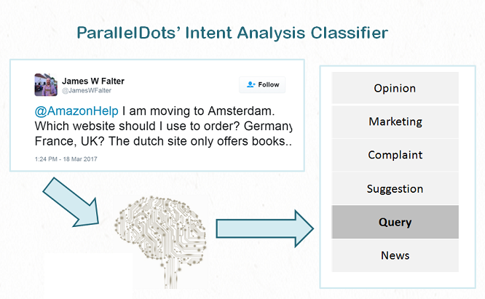

Contextual Semantic Search (CSS) :
Semantic search focuses on understanding the meaning of the search query and its content.

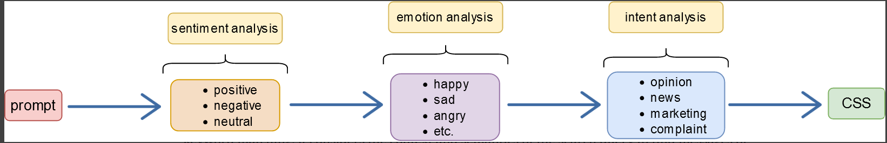

Applications:

Contextual semantic search has various applications across different domains.
- E-commerce:
- Content recommendations: used in recommendation systems to suggest personalized content to users based on their preferences, behavior. recommendations for articles, videos, music, news.
- Customer support and chatbots:

Uber: A deep dive analysis

- Facebook: 34,173 Comments
- Twitter: 21,603 Tweets
- News: 4,245 Articles

FACEBOOK
Sentiment Analysis
